Activation Report
ASAP 7.0.2 – WASS1133, JAMU66
ASAP-ORIGIN

August 27th, 2018

Contents

1 Activation Orders: JAMU66 Originated by CIS 3
1.1 JAMU66 Service Orders 3
1.2 Activation Orders Origin Distribution 4
2 Activation Orders: WASS1133 Originated by CIS 5
2.1 WASS1133 Service Orders 5
2.2 Activation Orders Origin Distribution 6

Activation Orders: JAMU66 Originated by CIS

JAMU66 Service Orders

ORIGINATING CIS | TOTAL | PERCENTAGE | COMPLETE | FAILED | TIMEOUT
CIS_JAMAICA | 41847 | 78.45% | 35139 | 6425 | 283
CIS_CAYMAN | 2171 | 4.07% | 2054 | 117 | 0
CIS_ANTIGUA | 679 | 1.27% | 645 | 34 | 0
CIS_ANGUILLA | 586 | 1.10% | 574 | 12 | 0
CIS_BARBADOS | 1233 | 2.31% | 1204 | 29 | 0
CIS_BVI | 904 | 1.69% | 902 | 2 | 0
CIS_DOMINICA | 837 | 1.57% | 832 | 5 | 0
CIS_GRENADA | 709 | 1.33% | 705 | 4 | 0
CIS_MNI | 70 | 0.13% | 58 | 12 | 0
CIS_SANTA_LUCIA | 1562 | 2.93% | 1545 | 17 | 0
CIS_ST_KITTS | 776 | 1.45% | 774 | 2 | 0
CIS_SN_VINCENT | 737 | 1.38% | 734 | 3 | 0
CIS_TKI | 907 | 1.70% | 669 | 238 | 0
OCA | 289 | 0.54% | 234 | 55 | 0
INTEGSSOFT | 0 | 0.00% | 0 | 0 | 0
CIS_172_21_64_99 | 35 | 0.07% | 18 | 17 | 0
ASAP TEST | 0 | 0.00% | 0 | 0 | 0
 | 53342 |  | 46087 | 6972 | 283

Activation Orders Origin Distribution

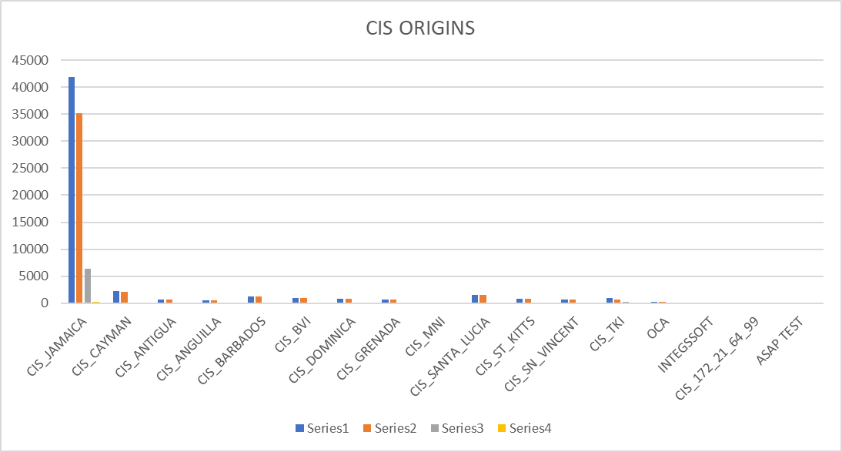

Activation Orders: WASS1133 Originated by CIS

WASS1133 Service Orders

ORIGINATING CIS | TOTAL | PERCENTAGE | COMPLETE | FAILED | TIMEOUT
CIS_JAMAICA | 19295 | 70.57% | 14493 | 3472 | 1330
CIS_CAYMAN | 0 | 0.00% | 0 | 0 | 0
CIS_ANTIGUA | 42 | 0.15% | 10 | 32 | 0
CIS_ANGUILLA | 837 | 3.06% | 608 | 229 | 0
CIS_BARBADOS | 0 | 0.00% | 0 | 0 | 0
CIS_BVI | 244 | 0.89% | 180 | 64 | 0
CIS_DOMINICA | 982 | 3.59% | 678 | 304 | 0
CIS_GRENADA | 2173 | 7.95% | 2042 | 131 | 0
CIS_MNI | 27 | 0.10% | 23 | 4 | 0
CIS_SANTA_LUCIA | 1100 | 4.02% | 1059 | 17 | 24
CIS_ST_KITTS | 1132 | 4.14% | 1029 | 103 | 0
CIS_SN_VINCENT | 1388 | 5.08% | 1310 | 78 | 0
CIS_TKI | 110 | 0.40% | 41 | 69 | 0
OCA | 9 | 0.03% | 4 | 5 | 0
INTEGSSOFT | 1 | 0.00% | 1 | 0 | 0
CIS_172_21_64_99 | 0 | 0.00% | 0 | 0 | 0
ASAP TEST | 0 | 0.00% | 0 | 0 | 0
 | 27340 |  | 21478 | 4508 | 1354

Activation Orders Origin Distribution

